Name: | Vasundhara Singh
UID no.: | 2021700062
Experiment No. | 2
Class: | SE CSE(DS)
Batch: | D-4
Date of Experiment: | 13/02/2023

AIM: | Experiment based on divide and conquer approach.
PROBLEM STATEMENT: | For this experiment, you need to implement Quick Sort and Merge Sort methods. Compare these algorithms based on time and space complexity. Generate 1,00,000 integer numbers using C/C++ Rand function and save them in a text file. Both the sorting algorithms uses these 1,00,000 integer numbers as input as follows. Each sorting algorithm sorts a block of 100 integers numbers with array indexes numbers A[0..99], A[0..199], A[0..299],..., A[0..99999]. You need to use a function to find the time required for 100, 200, 300.... 100000 integer numbers. Finally, compare the two algorithms by plotting the time required to sort 100000 integers using MS Excel. The x-axis of 2-D plot represents the block no. of 1000 blocks. The y-axis of 2-D plot represents the running time to sort 1000 blocks of 100,200,300,...,100000 integer numbers.
THEORY: | 1.) Quicksort is the widely used sorting algorithm that makes n log n comparisons in average case for sorting an array of n elements. It is a faster and highly efficient sorting algorithm. This algorithm follows the divide and conquer approach.  - Divide: In Divide, first pick a pivot element. After that, partition or rearrange the array into two sub-arrays such that each element in the left sub-array is less than or equal to the pivot element and each element in the right sub-array is larger than the pivot element.  - Conquer: Recursively, sort two subarrays with Quicksort.  - Combine: Combine the already sorted array.  Quicksort picks an element as pivot, and then it partitions the given array around the picked pivot element. In quick sort, a large array is divided into two arrays in which one holds values that are smaller than the specified value (Pivot), and another array holds the values that are greater than the pivot. After that, left and right sub-arrays are also partitioned using the same approach. It will continue until the single element remains in the sub-array.  2.) Merge sort is a sorting technique based on divide and conquer technique. With worst-case time complexity being Ο(n log n), it is one of the most respected algorithms. Merge sort first divides the array into equal halves and then combines them in a sorted manner.  Merge sort keeps on dividing the list into equal halves until it can no more be divided. By definition, if it is only one element in the list, it is sorted. Then, merge sort combines the smaller sorted lists keeping the new list sorted too.
PROGRAM: | #include <stdio.h>  #include <stdlib.h>  #include <time.h>  void rand_int()  {  int num1, num2;  long num;  FILE *ptr;  ptr = fopen("int.txt", "w");  srand( time(0));  for (long i = 0; i < 100000; i++)  {  num1 = rand();  num2 = rand();  num = num1 * 10 + num2;  fprintf(ptr,"%ld\n",num);  }  fclose(ptr);  }  void q_sort(long int n[],int first,long int last){  int i, j, pivot, temp;  if(first<last){  pivot=first;  i=first;  j=last;  while(i<j){  while(n[i]<=n[pivot]&&i<last)  i++;  while(n[j]>n[pivot])  j--;  if(i<j){  temp=n[i];  n[i]=n[j];  n[j]=temp;  }  }  temp=n[pivot];  n[pivot]=n[j];  n[j]=temp;  q_sort(n,first,j-1);  q_sort(n,j+1,last);  }  }  void merge(long int arr[], int l, int m, long int r)  {  int i, j, k;  int n1 = m - l + 1;  int n2 = r - m;  int L[n1], R[n2];  for (i = 0; i < n1; i++)  {  L[i] = arr[l + i];  }  for (j = 0; j < n2; j++)  {  R[j] = arr[m + 1 + j];  }  i = 0;  j = 0;  k = l;  while (i < n1 && j < n2) {  if (L[i] <= R[j]) {  arr[k] = L[i];  i++;  }  else {  arr[k] = R[j];  j++;  }  k++;  }  while (i < n1) {  arr[k] = L[i];  i++;  k++;  }  while (j < n2) {  arr[k] = R[j];  j++;  k++;  }  }  void m_sort(long int arr[], int l, long int r)  {  if (l < r) {  int m = l + (r - l) / 2;  m_sort(arr, l, m);  m_sort(arr, m + 1, r);  merge(arr, l, m, r);  }  }  int main()  {  rand_int();  FILE * ptr_int, * ptr_time;  ptr_time = fopen("times.csv", "w");  if(!ptr_time)  return 0;  fprintf(ptr_time, "Cases, Quick, Merge\n");  for(long int i = 100; i<=100000; i+=100)  {  ptr_int = fopen("int.txt", "r");  long int A[i], B[i];  clock_t start1, end1, start2, end2;  if(i % 1000 == 0)  {  printf("i = %ld.\n", i);  }  for(long int j = 0; j<i; j++)  {  fscanf(ptr_int, "%d\n", &A[j]);  B[j] = A[j];  }  start1 = clock();  q_sort(A, 0, i-1);  end1 = clock();  start2 = clock();  m_sort(B, 0, i-1);  end2 = clock();  double t1 = (double) (end1 - start1) / CLOCKS_PER_SEC;  double t2 = (double) (end2 - start2) / CLOCKS_PER_SEC;  fprintf(ptr_time, "%ld, %f, %f\n", i, t1, t2);  fclose(ptr_int);  }  fclose(ptr_time);  return 0;  }
GRAPH: | 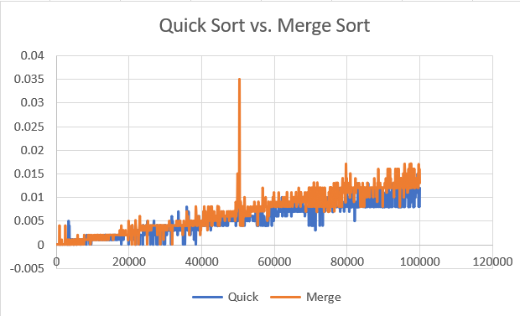
OBSERVATION: | Worst case scenario for Merge Sort among the given test cases occurs at the case containing around 50000 integers, marked by a sudden spike in its graph.  The generated set of test cases contained only average case scenarios for Quick Sort as we do not observe any sudden spikes in its graph.  Time complexity of merge sort is O(nlog(n)) as the entire input of n integers must be iterated through, and this must occur log(n) times (the input can only be halved log(n) times).  Time complexity of quick sort is O(nlog(n)) as there are log(n) partitioning "levels", and each level has to visit all n inputs.
CONCLUSION: | Time and Space Complexity of Merge and Quick Sort is  investigated.

